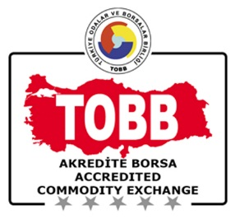
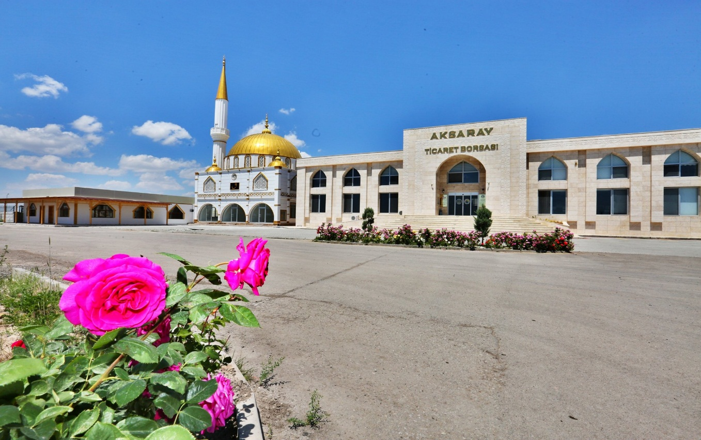
AKSARAY TİCARET BORSASI
2018 YILI
FAALİYET RAPORU

PERSONELE VERİLEN MESLEKİ EĞİTİMLER

PERSONELE VERİLEN KİŞİSEL GELİŞİM EĞİTİMLER

PERSONEL TARAFINDAN KIYASLAMA YAPILAN KURUMLAR

PERSONEL MEMNUNİYET ANKET PUANLARI

PERSONELE YÖNELİK DÜZENLENEN ETKİNLİKLER

WEB SİTELERİNİN ZİYARETÇİ SAYISI
Ocak-Aralık ayları arasında web sitemizi 2500 kişi ziyaret etmiştir.

SOSYAL MEDYA HESAPLARININ TAKİPÇİ SAYISI
Ocak- Aralık ayları arasında 1600 takipçisi vardır.

ÜYELERE YÖNELİK DÜZENLENEN ETKİNLİKLER

ZİYARET EDİLEN ÜYE SAYISI
- Ortaköy’de 45 adet
-Eskil’de 34 adet
-Ağaçören’de 3 adet
üye ziyaret edilmiştir.

ÜYE MEMNUNİYET ANKET PUANLARI

ÜYELERE YÖNELİK GERÇEKLEŞTİRİLEN VE DESTEKLENEN EĞİTİMLER

EĞİTİMLERE KATILAN ÜYE ORANI

ÜYE EĞİTİM MEMNUNİYET PUANI

MECLİS TOPLANTILARINA KATILIM ORANI

PERSONEL TOPLANTI KATILIM ORANI

AKREDİTASYON İZLEME KURULU TOPLANTISI KATILIM ORANI

HESAP İNCELEME KOMİSYONU TOPLANTISI KATILIM ORANI

YÖNETİM KURULU TOPLANTISI KATILIM ORANI

AKSARAY TİCARET BORSASI
2016-2017-2018-2019-2020 YILLARI
KARŞILAŞTIRMALI MALİ ANALİZ TABLOSU

 | 2016 | 2017 | 2018 | 2019 | 2020
GELİR | 3.668.566,38 | 4.222.227,47 | 4.290.216,97 | 5.494.595,97 | 6.926.991,47
GİDER | 2.343.472,33 | 2.582.568,14 | 2.913.535,60 | 3.178.249,98 | 3.268.341,57
KAR/ZARAR | 1.325.094,05 | 1.639.659,33 | 1.376.681,37 | 2.316.345,99 | 3.658.649,90
GELİR  ARTIŞ ORANI | 11,80 | 11.50 | 1,61 | 28,07 | 20,67

2018 YILI AKSARAY TİCARET BORSASI İŞE ALINAN - AYRILAN PERSONEL SAYISI

2018 Yılında Aksaray Ticaret Borsası’na 2 yeni personel alınmıştır.
2018 Yılında Aksaray Ticaret Borsası’ndan 1 personel işten ayrılmıştır

2018 STRATEJİK PLAN GERÇEKLEŞME ORANI %75 OLDUĞU GÖRÜLMÜŞTÜR.

